Kendall DE – 3D Design
Relief Sculpture Project

Objective: To use only one shape (and parts of that shape) as well as the elements and principles of design to create a non-objective relief sculpture made of foam core.

Materials:

Sketchbook
Pencil
Tracing Paper
Black Sharpie Marker
Rubber Cement
Foam Core Board
Ruler
X-acto Blade
Self-Healing Cutting Mat
6x6 white tag board
10x10 Black Crescent Board

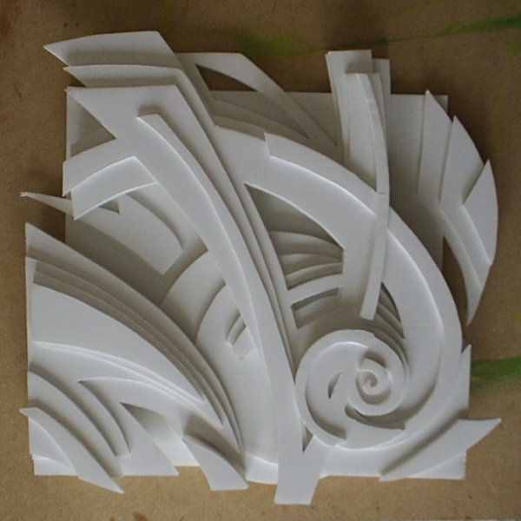
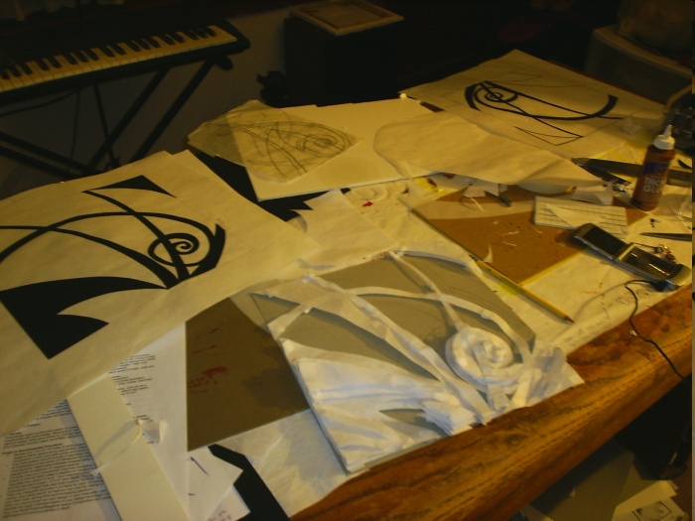
Vocabulary:
Relief Sculpture
Bas relief
High Relief
Non-Objective
Dry Mounting
Thumbnail Sketch

Directions:
- Choose a simple geometric shape (i.e. square, circle, triangle, rectangle, etc.)
- Create 5 - 6 Thumbnail sketch designs on a 6” x 6” squares
- Choose your most successful design and think about which areas will become convex or concave (raised or lowered) and lightly sketch it onto a 6” x 6” piece of white tag board.
- Carefully cut foam core board into pieces and use rubber cement to dry mount each piece where you would like to add depth.
- When finished, dry mount onto 10” x 10” black crescent board with your name written neatly on the back.

Rubric:
5 pts - Minimum of 5 Thumbnail Sketches (1pt each)

15 pts - Composition (5pts each)
- The overall design is pleasing to the eye and has a strong focal point.
- The foam core was used to add appropriate and interesting depth to the piece.
- The shape chosen was integrated and repeated in complex ways that create rhythm and movement.

10 pts - Craftsmanship (2pts each)
- The foam core was cut neatly with no rough edges.
- It was glued carefully with no excessive glue drips or splotches.
- It was centered carefully when glued to black backing.
- There are no erase marks, smudges, rips, tears, etc.
- It is sturdy enough to withstand normal movement/transportation

